

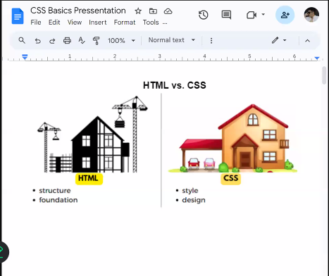

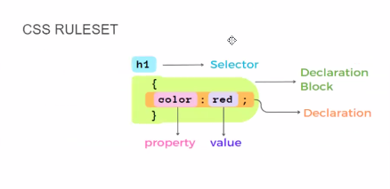

Internal

External

In-line

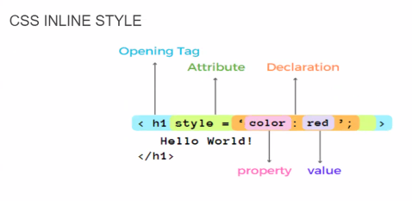

The correct way

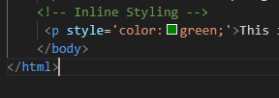

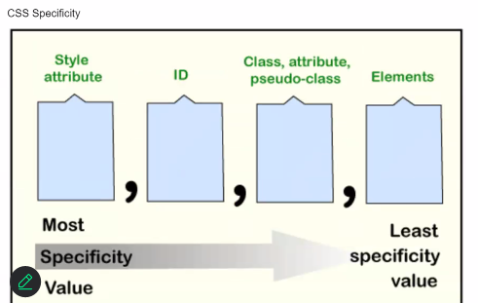

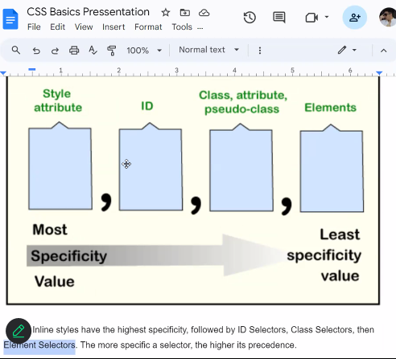

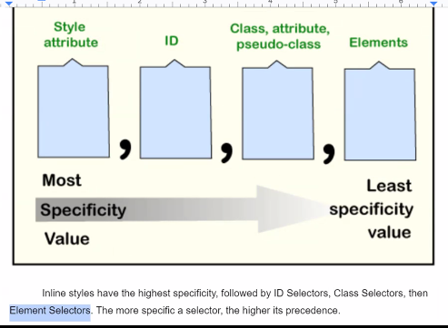

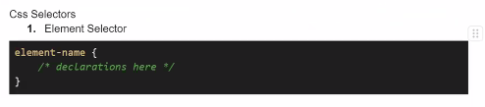

Inline>ID>Class>element

**Inline Styles** (highest specificity)  
**ID Selectors**  
**Class, Attribute, Pseudo-Class Selectors** (equal specificity)  
**Element Type, Pseudo-Element Selectors** (equal specificity)  
**Universal Selector (*)** (lowest specificity)

Specificity is a way for browsers to determine which CSS rule applies to an element when multiple rules target the same element. The rule with the highest specificity wins.  
(***the more specific it is, the higher priority it will have*** )  
  
  
If multiple rules have the same specificity, the order they appear in the CSS code (cascade order) is used to determine which one is applied. The latter rule takes precedence.

Inline>Internal>External

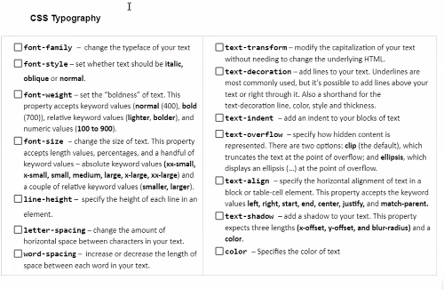

/* Naming conventions */  
Camel Casing: fontFamilySize  
Khebab Casing: font-family-size (usually used for css)

<!DOCTYPE html>

<html>

<head>

  <link rel="stylesheet" type="text/css" href="background.css">

</head>

<body>

  <h1>CSS Colors, Backgrounds, and Images Example</h1>

  <h2>Color Values</h2>

  <p class="color-example">This is an example of different color values.</p>

  <h2>Background Colors and Images</h2>

  <div class="background-example">

    <p>This is an example of a background color.</p>

  </div>

  <h2>Background Positioning and Repeating</h2>

  <div class="background-position-example">

    <h2>This is a sample heading</h2>

    <p>This is an example of a background image with different positioning and repeating.</p>

  </div>

  <h2>Opacity and Transparency</h2>

  <p class="opacity-example">This is an example of opacity and transparency.</p>

  <h2>Adding Images to Web Pages</h2>

  <img src="image.jpg" alt="Example Image" class="image-example">

  <h2>Image Sizing and Alignment</h2>

  <img src="image.jpg" alt="Example Image" class="image-sizing-example">

</body>

</html>